Name____________________________________ Date______ Class____

Title: The Case of the Vanishing Scallops
Introduction: You will be designing a research plan to investigate causes or propose solutions for the declining bay scallop population.
- Using graphs to identify the problem: plot the data shown on the graph below. What are three things you notice from the information on the graph?

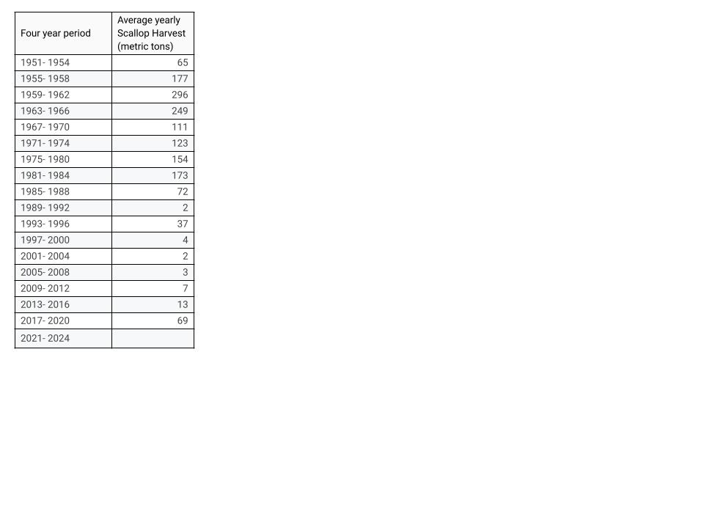
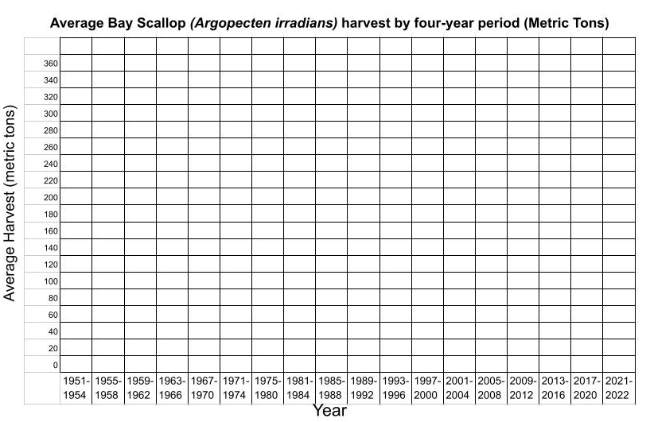

Thinking deeply about data:

What does “scallop harvest” mean? Who harvests scallops? For what purpose?

- Does a changing scallop harvest necessarily imply a decline in the scallop population? What else, besides declining population, could result in smaller harvests?

- What additional information would you need to determine if lower scallop harvest were due to declining populations of scallops?

Thinking deeply about the problem:

Think about what you just watched. Develop 5 pertinent questions about the scallop die-off that could help you discover:

The cause of the die-off and how to prevent it from recurring

The effects of the die-off on the surrounding ecosystem

