Name____________________________________ Date______ Class____

Title: Acid in the Ocean: Not a Shell (Building) Game

Introduction:
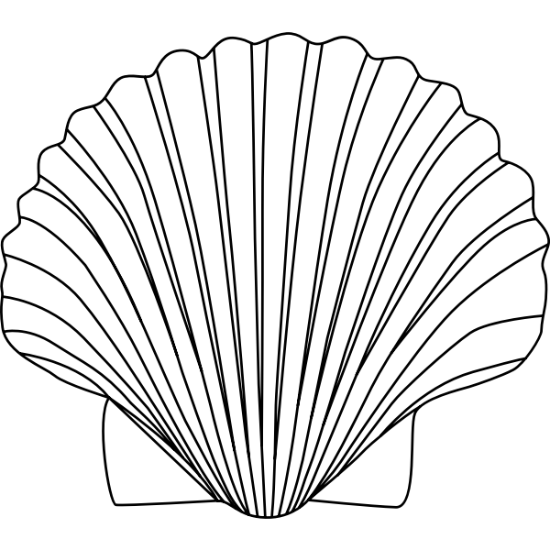
In this activity, you will simulate the effects of ocean acidification on marine organisms. By building "shells" using LEGO bricks, you will experience firsthand how increasing levels of carbon dioxide in the atmosphere can impact the ability of marine organisms to build and maintain their shells.
Lego | Ion/ molecule
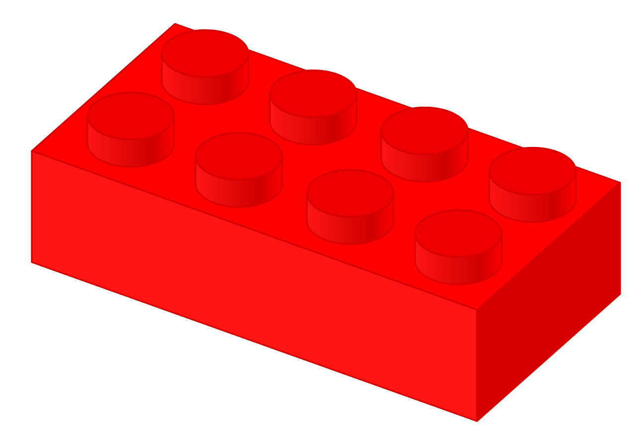 | H+ (Hydrogen)  *amount determines pH of seawater
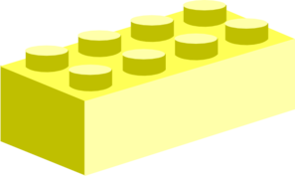 | CO₃ (Carbonate)
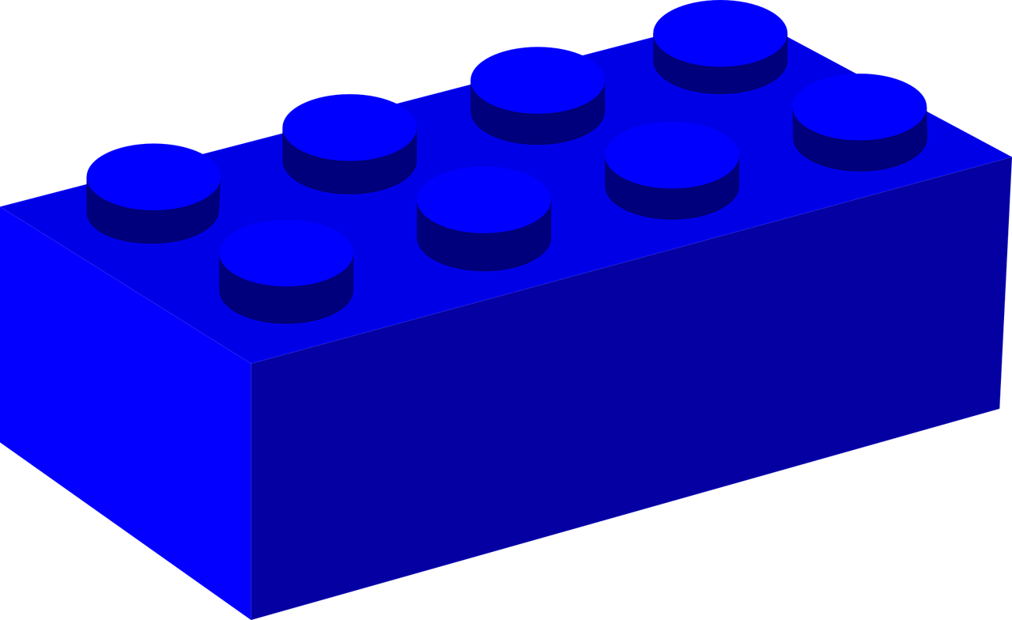 | Ca+ (Calcium)
 | CaCO₃ (Calcium Carbonate)
 | HCO₃⁻ (Bicarbonate)

Materials:
  - A bag of Lego bricks (blue, yellow, and red)
  - A timer
  - Student Worksheet

Rules:
- Players set the timer for 1 minute. Players reach into the bag and grab one (1) Lego at a time. They may not look in the bag to choose their blocks.
- Player IMMEDIATELY pairs that with an available lego based on rules below.
Note: Red and blue blocks never connect and neither do two (2) blocks of the same color. If there is no available match, wait until next turn.
- The carbonate ions (yellow Legos) are very attracted to and bond eagerly with the hydrogen ions (red Legos)
- The carbonate ions (yellow Legos) will bond with calcium (blue Legos) to build a shell, but NOT if hydrogen ions (red Legos) are available to bond with. (Yellow likes blue but PREFERS red)
- When the carbonate ions (yellow Legos) connect or bond with hydrogen ions (red Legos) they form bicarbonate, which is not useful for many forms of sea life.
- Students should quantify how many pairs of calcium carbonate they formed and record the number. This represents the growth in their animal.

Procedure:
- Simulating Ocean Acidification:
- Round 1 (Pre-Industrial Era):
  - Disconnect and place 12 yellow, 12 blue, and 2 red Legos in a bag. The amount of red Legos (representing hydrogen ions) in this round reflects the amount of hydrogen found in seawater before industrial times.
  - Set timer for 60 seconds, proceed following rules above.
  - Record results in data table.
- Round 2 (Industrial Era):
  - Place 12 yellow, 12 blue, and 3 red Legos in a bag. The amount of red Legos represent the amount of hydrogen found in seawater in 2018. This represents the increase in ocean acidity.
  - Set the timer for 60 seconds, proceed following the rules above.
  - Record results in data table.
- Round 3 (Future Scenario):
  - Disconnect and place 12 yellow, 12 blue, and 6 red Legos in a bag. The amount of red Legos (representing hydrogen ions) in this round reflects the continued rise of carbon dioxide released in the atmosphere; it is predicted that the ocean will become nearly 150% more acidic by the end of the century.
  - Set the timer for 60 seconds, proceed following the rules above.
  - Record results in data table.

Results:
 | CaCO₃ pairs | HCO₃⁻ pairs
Round 1
Round 2
Round 3

Round 1
(pre industrial)
Round 2
(current times)
Round 3
(future: based on continuing current levels of CO2 emissions)
Calcium Carbonate (CaCO3) Pairs
1
3
6
9
12

Conclusions:
- Which round had the most CaCO₃ pairs? Why do you think that was?

- In which round did the seawater have the lowest pH? Highest?

- If we continue to burn fossil fuels at the same rate, what do you think will happen to the shell-building animals in marine environments?

- How does this activity relate to the real-world problem of ocean acidification?

- What can humans do to mitigate the effects of ocean acidification?

